**M.HARITHABANU**

**au812921106016**

**smharithabanu@gmail.com**

USING IOT

**ENVIRONMENTAL MONITORING**

INTRODUCTION:

The demand of service over the internet necessitated the data collection and exchange in an efficient manner. Internet of Things refers to the rapidly growing network of connected objects that are able to collect and exchange data using embedded sensors. It is nowadays finding profound use in each and every sector and plays a key role in the proposed environmental monitoring system too IoT converging with cloud computing offers a novel technique for better management of data coming from different sensors, collected and transmitted by low power, low cost microcontroller "Arduino UNO" An open source website, Thingspeak is used where the measurement of the parameters are updated. Thingspeak is an open source Internet of Things application and API in store and retrieve data from the sensors using the HTTP Protocol over the Internet. Thingspeak is an loT analytics platform service that allows you to aggregate, visualize, and analyze live data streams in the cloud. The cloud utilizes the operations of Graphical visualization and available in the form of virtual server for the users and the objects are communicated with the cloud via possible 'wireless internet connections available to the users and the majority objects uses the sensors to tell regarding the environmental analogue data. The loT helps being all things together and permits us to communicate with our very own things. The measurements,thus received can be viewed in these scripts such as JSON, XML and CSV. In the proposed system, the environmental parameters can directly be accessed by the user, thus eliminating the need for third parties.

BLOCK DIAGRAM

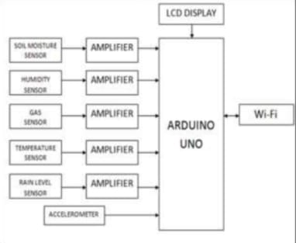

Internet of Things refers to the rapidly growing network of connected objects that are able to collect and exchange data using embedded sensors. It is nowadays finding profound use in each and every sector and plays a key role in the proposed environmental monitoring system too. IoT converging with cloud computing offers a novel technique for better management of data coming and stores it. The working process of the Internet of Things is shown below.

The proposed system keeps track on the parameters such as moisture, temperature, humidity, rainfall, gas content and earthquake intimation with the help of the real time sensors. These parameters are continuously monitored by an open source platform called Thingspeak for an interval of every 2 minutes. The data can be viewed in any one of the three formats such as JSON, XML and CSV. The sensors in the proposed systent collect the data such as the temperature, humidity, soil moisture, pollution level, rain water level and movement in the earth surface. The Wi-Fi network helps in the process of sending the collected data to the open source platform. Thingspeak. Alternate to that, an app is made for the purpose of viewing the collected data in even more easier manner. Through the application/Thingspeak, the user will be able to know about the status of his/her own agricultural land.

Recently climatic change and environmental monitoring and management has received much attention. The paper introduces three different loT based wireless sensors for environmental and ambient monitoring: one employing User Datagram Protocol (UDP)-based Wi-Fi communication, one communicating through Wi-Fi and Hypertext Transfer Protocol(HTTP) and third one using Bluetooth Smart. The above presented systems help in recording data at remote locations and viewing it from every device with an Internet connection. Here Zigbee is used to monitor and control application where wireless connectivity is required. UDP based cyber physical system monitors the temperature and relative humidity. Here the losses are caused by the network itself. The WFi sends the UDP or HTTP packets to a Cloud Platform which makes it available only to the administrator who decides whether the data must be public or private. BLE consist of sensors placed at various areas at which they produce a beacon when data is received and the server takes the information from the sensors whenever the beacon is produced.anter-measures can be taken after the keen observation of the parameters of the land.

PROGRAM:

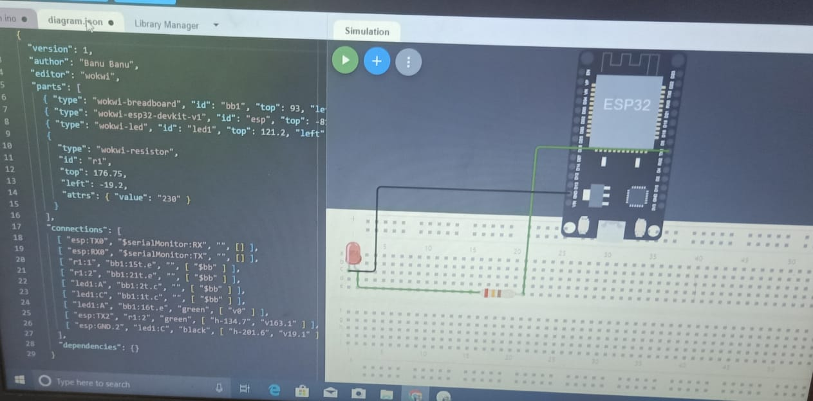

#include "DHT.h"

#define DHTPIN 15

#define DHTTYPE DHT22

DHT dht (DHTPIN, DHTTYPE);

void setup() {

Serial.begin(9600);

Serial.println(F("DHTxx test!"));

dht.begin();

}

void loop() {

delay(2000);

float h = dht.readHumidity();

// Read temperature as Celsius float t dht.readTemperature();

float t = dht.readTemperature();

// Read temperature as Fahrenheit float f dht.readTemperature(true);

Float f = dht.readTTemprature(true);

// Check

if (isnan(h) || isnan(t) || isnan(f)) { Serial.println(F("Failed to read from DHT sensor!"));

return;

}

// Compute heat index in Fahrenheit float hif dht.computeHeat Index(f, h);

float hif = dht.computerHeatIndex(f,h);

// Compute heat index in Celsius float hic dht.computeHeat Index(t, h, false);

float hic = dht.computerHeatIndex(t,h.false);

Serial.print(F("Humidity: "));

Serial.print(h);

Serial.print(F("% Temperature: "));

Serial.print(t);

Serial.print(F("°C "));

Serial.print(f);

Serial.print(F("F Heat index: "));

Serial.print(hic);

Serial.print(F("°C "));

Serial.print(hif);

Serial.println(F("F"));

}

This program creates a simple EnvironmentalMonitor class that simulates sensor data for temperature, humidity, and air quality. The `read_sensor_data()` method simulates reading data from sensors, and the `display_data()` method prints the sensor readings. The program continuously monitors and displays the data in a loop with a 5-second interval.